

**Special Educational Needs and Disability Information Report**

January 2025 – 26

**Contents:**

|  |  |  |
| --- | --- | --- |
|  |  | **Page** |
| **1.** | Amblecote SEN Team | **2** |
| **2.** | Objectives | **3** |
| **3.** | How do we identify Special Educational Needs in pupils? | **3-4** |
| **4.** | What are Special Educational Needs and Disabilities? | **4-5** |
| **5.** | What additional resources are specifically related to the areas of SEND? | **5-6** |
| **6.** | What is our Wave Provision for SEND children? | **7-8** |
| **7.** | Who is responsible for SEND at Amblecote? | **8** |
| **8.** | What expertise and staff training are available to support pupils with SEND? | **8-11** |
| **9.** | 1. How is progress monitored? | **11** |
| **10.** | How do we involve pupils and parents/carers? | **11** |
| **11.** | What are the accessibility arrangements at Amblecote Primary School? | **12** |
| **12.** | How do we support transition? | **12** |
| **13.** | How do we support Looked after Children (CLA) with Special Educational Needs or Disabilities? | **12-13** |
| **14.** | What complaints procedures are in place for parents/carers of pupils with SEND? | **13** |
| **15.** | Other relevant information and school policies. | **13** |

**Meet the Amblecote SEN Team**

**SENDCo – Mrs G Dunckley**

*Welcome to Amblecote!*

Please feel free to contact us with any questions or concerns, however big or small. The team aim to foster close relationships with parents/carers, and we are always happy to talk things through.

**Mrs Gill Dunckley**

SENDCo

**Working days – Monday, Tuesday, Wednesday, Thursday**

Email: [gdunckley@amblecote.dudley.sch.uk](mailto:gdunckley@amblecote.dudley.sch.uk)

Telephone: (main reception) 01384 818335

**SEN & Pastoral Support – Miss A Edwards**

Miss Edwards has specific training in nurture, trauma, attachment difficulties, bereavement and mental health. Being non-class based, Miss Edwards can offer support to any pupil across the whole school as and when required.

**Miss Alyson Edwards**

SEN & Pastoral Support - HLTA

**Working days – Monday, Tuesday, Wednesday, Thursday, Friday**

Email: [aedwards@amblecote.dudley.sch.uk](mailto:aedwards@amblecote.dudley.sch.uk)

Telephone: (main reception) 01384 818335

**Objectives:**

**At Amblecote, our objective for all pupils with Special Educational Needs or Disabilities is to ensure that we address any barriers to learning that they may face. We are committed to the process of inclusion and endeavour to provide full access to the national curriculum for all. We seek to identify the needs of our pupils and respond with a range of teaching strategies to provide support that allows our pupils to be independent life-long learners, happy and healthy and achieve their full potential.**

**How do we identify Special Educational Needs in pupils?**

There are systems and processes in place, which allow us to quickly identify children who may require additional support. Children could be identified for the following reasons:

* they are performing below age related expectations.
* they are not making expected progress.
* concerns have been raised by parents/carers of the child.
* concerns have been raised by staff.
* liaison with external agencies.
* due to a health diagnosis.
* we are alerted to possible social, emotional, or mental health issues.

Children will be monitored by their class teacher and the SENDCo through the ‘Assess, Plan, Do, Review’ graduated approach. As a first step, children with cognition and learning needs will be assessed using Birmingham SEN Toolkits. A ‘next steps’ document will be generated and shared between SENDCo, class teacher and parent.

If children are still not making sufficient progress, then appropriate outside agencies may need to be involved to provide specific support. If the highlighted need is impacting upon the pupil’s learning, they will then be placed on the SEND register. This is a collaborative process with parents. Once a child has been placed on the register, they will have an **Individual Target Plan (ITP)** written. This plan will be reviewed each term. These will be discussed with both pupils and parents/carers.

If the pupil is working at age expectations but requires social and/or emotional support within school, a **pupil passport** will be created with school and home. This passport, capturing the child’s voice, will clearly show:

* the pupil’s specific need/diagnosis.
* how these impact upon their learning.
* difficulties they may face in the classroom/playground.
* strategies of support to reduce barriers to learning.
* strategies for the child to help support their needs.
* additional provision in place.

If a child has complex and significant SEND then an application will be made for an **Education, Health and Care Plan (EHCP).** The decision made to provide support for pupils with additional needs is made through collaborative working with all agencies, including parents/carers and pupils.

**What are Special Educational Needs and Disabilities?**

There are four areas of need stated in the SEND Code of Practice 2014:

* **Communication and Interaction** - Difficulty with different aspects of speech, language, or social communication.
* **Cognition and Learning** - Moderate and severe learning difficulties including specific learning difficulties such as dyslexia and dyscalculia.
* **Social, Emotional and Mental Health Difficulties** - Difficulties such as anxiety, depression, or self-harming, etc.
* **Sensory and/or Physical -** Difficulties such as visual or hearing impairment.

At Amblecote Primary, **the primary area of need is Communication and Interaction.**

Below, shows the breakdown of the four areas of need across the school.

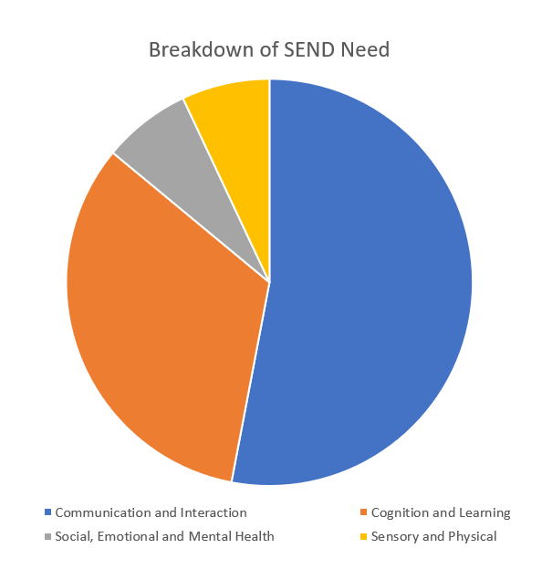

|  |  |
| --- | --- |
|  | |
| Communication and Interaction | **53%** of our pupils on the SEND Register require support within this area of need.   * *Out of this percentage, 33% of pupils have a diagnosis of Autism Spectrum Condition (ASC).* |
| Cognition and Learning | **33%** of our pupils on the SEND Register require support within this area of need. |
| Social, Emotional and Mental Health | **7%** of our pupils on the SEND Register require support within this area of need. |
| Sensory and/or Physical | **7%** of our pupils on the SEND Register require support within this area of need. |

Provision is made for pupils whose needs fall into one or more of these categories. Although behaviour is not a category in itself, at Amblecote we feel poor behaviour is often an indicator to an unidentified SEND in one or more of these areas.

**What additional resources are specifically related to the areas of SEND?**

|  |  |
| --- | --- |
| **Communication and Interaction**  **(ASC and SLCN)** | **Cognition and Learning** |
| * Effective classroom teaching with use of visual cues and support. (Quality First Teaching) * Communicate-in-Print 3 software to produce visual class materials and individualised visual support. * Small group targeted interventions to develop skills in language and social interaction. * Access to advice and support from Dudley Speech and Language Therapy Service. * Access to advice, support, staff training, communication audits and pupil 1:1 therapy from ECHO (the outreach team from the Speech and Language Centre). * Involvement of Amblecote’s Independent Speech and Language Therapist to assess and support complex communication needs. * Access to advice and support from CIPS – Communication, Interaction, Physical and Sensory Service. * Use of specialist approaches to aid attention and listening – ‘Attention Autism’. * Use of ‘Talkabout – A Social Communication Skills package within small social groups. | * Effective classroom teaching with use of visual cues and support. (Quality First Teaching) * Systematic and effective teaching of phonics in the early years and across the school as appropriate. *(Little Wandle Phonic Programme)* * Interventions in speaking and listening, reading, writing and/or maths – *Birmingham SEN Toolkit.* * Use of NAPA phonic assessments. * Individual Target Plans (ITP) showing granular next steps and one-page profiles. * Clear visual supports and displays. * Access to specialist support from Occupational Therapists and Learning Support Service (LSS). * Access to specialist support from Educational Psychologist (EP) * Edukey Provision Mapping software to monitor and assess effectiveness of interventions and child’s progress. * Literacy Gold – Reading/Writing intervention and Dyslexic Screening Tool. |
| **Social, Mental and Emotional Health** | **Sensory and Physical Needs** |
| * Pastoral Support (Miss Edwards) – short-term block therapy within school. * Access to specialist support from Educational Psychologist. * Access to ‘Reflexions’ – Mental Health Support Team. * Access to Arts of Change – charity based SEMH support service. * Access to Sycamore Behavioural Outreach Team. * Refer to CAMHS Single Point of Access (SPOA). Pupil can then be triaged to Mental Health Charities Consortium, e.g. What? Centre, The Arts of Change Trust, Phase Trust and Black Country Mental Health Charity. * Small group targeted interventions to develop skills in language and social interaction. * Small group targeted intervention specifically with EHCP pupils to develop life skills. * Access to Lego Therapy * Access to local family support hub, Stourbridge Family Support Centre. * Referral to Early Help. * Referral to Triple P/Stepping Stones. * Access to school nurse referral – Lucy Millard. | * Access to CIPS – Sensory support from specialist teachers and TAs. * Access to specialist equipment and resources. * Trained members of staff to support and increase independence. * Fully accessible school building. * Access to advice and support from NHS practitioners (e.g. Occupational Therapy, Physiotherapy) * Trained staff to support medical needs. * PEEPs and risk assessments in place written with support from PD – Physical Disability. |

**What is our Wave Provision for SEND children?**

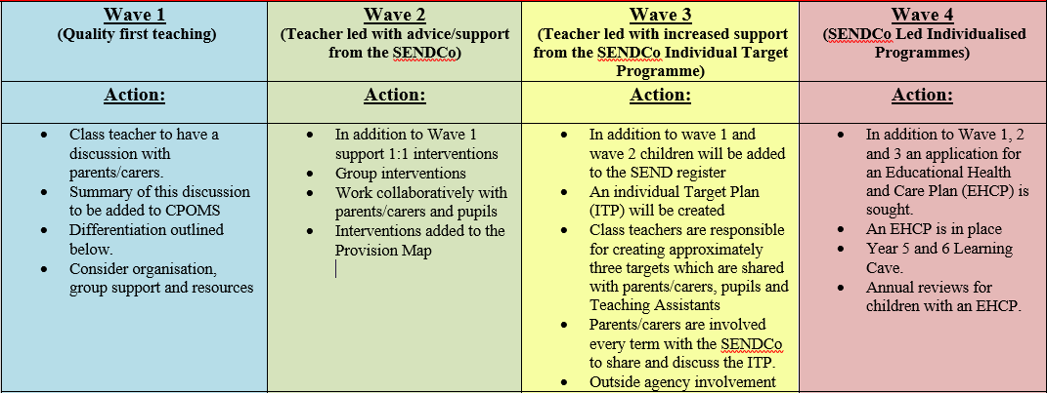At Amblecote, we have four waves of provision.

***To view the whole school provision ‘Wave System’, please find the document under SEND on our school website.***

All our children are taught through effective Quality First Teaching. Our teachers have high expectations, considering the different learning styles of children in their class and continually assessing them through assessment for learning. Differentiating the curriculum helps children to achieve their full potential.

When children with SEND need more than Wave 1 (Quality First Teaching), interventions are delivered in a variety of ways to meet the needs of the individual. These may be small group or individual time limited interventions that will either be delivered by a teacher or a school teaching assistant. These interventions will be monitored over a 12-week period to assess impact.

If your child’s needs cannot be met through Quality First Teaching and class-based intervention groups, specialist input may be sought. This type of support is available for children to help identify specific barriers to their learning. Specialist professionals from external agencies may help by assessing children and offering specific targets and recommendations to be used within the classroom.

We use the expertise of the Dudley Services to assess and report on our children. These include Learning Support, Educational Psychology, Occupational Therapy, Physiotherapy, Child and Adolescent Mental Health Service (CAMHS) and CIPS (Communication, Interaction, Physical and Sensory) to assess some children with specific concerns or needs.

Those children whose learning needs are significant and complex and as such, require more than 20 hours’ adult support, may need individual, specific support provided by an Education, Health and Care Plan (EHCP). This means the class teacher and SENDCo will have identified your child as needing a particularly high level of individual or small group teaching which cannot be provided from the current ordinarily available inclusive provision across the authority. A request for an EHC Plan is sent to the Local Authority for consideration. Only children with the most complex and significant needs are granted an EHCP.

**Who is responsible for SEND at Amblecote?**

SENDCo, Mrs Gill Dunckley ([gdunckley@amblecote.dudley.sch.uk](mailto:gdunckley@amblecote.dudley.sch.uk)), supported by Miss Alyson Edwards – SEN/Pastoral Support ([aedwards@amblecote.dudley.sch.uk](mailto:aedwards@amblecote.dudley.sch.uk)) are responsible for:

* Co-ordinating the support for children with special educational needs or disabilities (SEND) and developing the school’s SEND policy to make sure all children get a consistent, high-quality response to meeting their needs in school.
* Ensuring that parents/carers are kept involved and informed about the support their children are receiving.
* Liaising with external professionals who may be coming into school to help support your child’s learning, e.g. Speech and Language Therapy, Educational Psychology etc.
* Updating the school’s SEND register (a system for ensuring all the SEND needs of pupils in this school are known) and making sure that there are excellent records of your child’s progress and needs.
* Providing specialist support for teachers and support staff in the school so they can help children with SEND in the school achieve the best progress possible.
* Ensuring there is sufficient expertise in school and providing or facilitating training where required.

**What expertise and staff training are available to support pupils with SEND?**

The school is fully committed to working with other agencies such as health, social care, local authority support services and the voluntary sector.

Directly funded by the school:

* Educational Psychologist
* Learning Support Service

Paid for centrally by the Local Authority but delivered in school:

* Speech and Language Therapy (provided by Health but paid for by the Local Authority)
* Inclusive Early Years’ Service
* Dudley Disability Team
* CIPS – Communication, Interaction, Physical and Sensory Advisory Service
* ECHO Team
  + ASC Team
  + Visual/Hearing Impairment Teams
  + Physical Disability
* CAMHS
* ‘Reflexions’ – part of CAMHS – Mental Health Support Team
* Sycamore Behaviour Support Team
* Social Worker
* Stourbridge Family Centre/Family Support Worker

Provided and paid for by the Health Service but delivered in school:

* School Nurse/Health Visitor
* Continence Team
* Occupational Therapy
* Physiotherapy
* Wheelchair Services

Voluntary organisations

* Arts of Change
* SENDIASS (Special Educational Needs and Disabilities Information Advice and Support Service) formerly Dudley Parent Partnership

There is a wealth of experience amongst the teaching staff and training has included ASC (Autistic Spectrum Condition), Attachment Disorder, Social Stories, Lego Therapy as well as interventions including Precision Teaching and supporting pupils with learning and memory difficulties.

**The contact details of support services for parents of SEND pupils**

Local Authority – 01384 814398

Educational Psychology Service – 01384 814359

Learning Support Service – 01384 813736

Speech and Language Therapy – 01384 321375

Communication, Interaction, Physical and Sensory Service (CIPS) -

Parent carers, education settings and health professionals can make a request for support to CIPS by:

* Email: [CIPS@dudley.gov.uk](mailto:CIPS@dudley.gov.uk)
* Telephone: [01384 816974](tel:01384816974)

You will then be sent a request for support form to complete.

Occupational Therapists – 01384 366912

Integrated Early Years Service – 01384 814364

Special Educational Needs and Disabilities Information Advice and Support Service (SENDIASS) – 01384 817373

**School offer information with regards to the Early Help pathway – support within the home.**

**Family Hub Locations and Contact Details -**

**Stourbridge**

Forge Rd, Stourbridge, DY8 1XF.

01384 818780

**Lye**

Lye By-Pass, Stourbridge, DY9 8HT.

01384 813954

**Brierley Hill**

18 Parkes Street, Brierley Hill, DY5 3DY.

01384 813322

**Coseley**

Bayer Street, Bilston, WV14 9DS.

01384 813096

**Dudley**

Selbourne Road, Dudley, DY2 8LJ.

01384 812440

**Dudley Parenting Service**

**For parenting programmes, NVR or reducing parental conflict information, go to: www.dudleyparents.co.uk or email** [**parenting@dudley.gov.uk**](mailto:parenting@dudley.gov.uk)

**Triple P online**

How parents complete Triple P online:

• Go to http://www.dudleyparents.co.uk.

• Register and they send a log in code (this may appear in the junk folder)

• If you have any problems email [**parenting@dudley.gov.uk**](mailto:parenting@dudley.gov.uk)

**SENDIASS**

1. Free, confidential, and impartial support to children and young people aged 0-25 years old with SEND and their parents and carers.
2. Provides legally based advice, information and support on all matters relating to SEN and disabilities including health and social care issues.

**Further information**

1. https://www.dudley.gov.uk/residents/learning-and-school/information-for-parents/dudley-sendiass/
2. Contact: [dudley.sendiass@dudley.gov.uk](mailto:dudley.sendiass@dudley.gov.uk) or by contacting our office mobiles 07900 161363 or 07929 777744.

**Dudley’s Local Offer:**

Dudley's Local Offer is a one stop resource of information and services available to children and young people (aged 0-25) with Special Educational Needs and/or Disabilities (SEND), their parents, carers, and families.

[**https://www.dudley.gov.uk/residents/dudleys-local-offer/**](https://www.dudley.gov.uk/residents/dudleys-local-offer/)

**How is progress monitored?**

In accordance with the SEND Code of Practice (2014) the process for responding to children identifies as needing additional support, follows the four-step cycle called the Graduated Response.

* **Assess** - The child is assessed thoroughly to identify key areas of need.
* **Plan** - Plan provision that is needed to scaffold the child’s learning.
* **Do** - The support planned is put in place and monitored over a period of time.
* **Review** - Review progress against the child’s targets.

Your child’s progress is continually monitored by his/her class teacher. Their summative progress is reviewed every term, and an age-related assessment is given. This is the case for all children in school.

Children on the SEND register will have an Individual Target Plan (ITP) or Pupil Passport which will be reviewed termly and the plan for the next term made. The progress of children with an EHC Plan is formally reviewed at an Annual Review with all adults involved with the child’s education. The Class Teacher and SENDCo will also, through progress meetings, check that your child is making good progress within any individual work and in any group that they take part in.

**How do we involve pupils and parents?**

* The class teacher is regularly available to discuss your child’s progress or any concerns you may have and to share information about what is working well at home and school so similar strategies can be used.
* The SENDCo and/or Pastoral Support is available to meet with you to discuss your child’s progress or any concerns/worries you may have.
* All information from outside professionals will be discussed with you with either the person involved directly, or where this is not possible, in a report.
* A home/school contact book may be used to support communication with you, when this has been agreed to be useful for you and your child.
* Teachers will meet with both parents/carers and children to discuss Individual Target Plans termly.

**What are the accessibility arrangements at Amblecote Primary School?**

* The building is accessible to children with physical disability via ramps. All areas of the school are fully accessible to children with disabilities.
* We ensure that equipment used is accessible to all children regardless of their needs.
* After-school provision is accessible to all children including those with SEND.
* Extra-curricular activities are accessible for children with SEND. It may be necessary to make an individual risk assessment for some children for some activities. If this is necessary, we will discuss this with parents.

**How do we support transition?**

We recognise that transitions can be difficult for a child with SEND and take steps to ensure that any transition is a smooth as possible.

If your child is moving to another school:

* We will contact the new school’s SENDCo and ensure they know about any special arrangements or support that needs to be made for your child. We will make sure that all records about your child are passed on as soon as possible.
  + When moving classes in school:

Information will be passed on to the new class teacher in advance and a transition meeting will take place with the new teacher.

A transition timetable will be established.

A transition book/social story may also be used to help your child copy better with the changes.

In Year 6:

* The SENDCo will arrange a meeting with the secondary school to discuss the specific needs of your child and provisions in place.
* Where possible your child will visit their new school on several occasions and in some cases staff from the new school will visit your child in their present setting.
* If a transition book/social story would help your child then this, alongside a transition timetable, will be established.
* Your child will complete focused tasks about aspects of transition to support their understanding of the changes ahead.
* All paperwork will be passed on to the new setting.

**How do we support Looked after Children (CLA) with Special Educational Needs or Disabilities?**

A large percentage of CLA have some SEND. This makes them vulnerable both academically, emotionally and socially. We recognise this at Amblecote Primary School and work hard to support all our children.

All our CLA have education meetings (either termly or 6 monthly depending on the child’s local authority) when their Personal Education Plan (PEP) is reviewed. At this meeting, core professionals and carers meet to discuss and review previous targets and set new ones. We ensure that these targets are the focus of the child’s provision. The child’s pupil premium allocation is also discussed and agreed how this will be spent in the meeting.

The governor for CLA pupils is Mrs Claire Roberts. ([croberts@amblecote.dudley.sch.uk](mailto:croberts@amblecote.dudley.sch.uk))

**What complaints procedures are in place for parents of pupils with SEND?**

If you have concerns about your child's progress, you should speak to your child's class teacher initially. If you are not happy that the concerns are being managed and that your child is still not making progress, you should speak to the SENDCo or Head Teacher ([info@amblecote.dudley.sch.uk](mailto:info@amblecote.dudley.sch.uk)).

If you are still not happy, you can speak to the school Chair of Governors, Mrs Claire Roberts ([croberts @amblecote.dudley.sch.uk](mailto:vwaterfield@amblecote.dudley.sch.uk)).

Complaints procedure available on the school website or by following this link <https://www.amblecote.dudley.sch.uk/wp-content/uploads/2021/02/Amblecote-Complaints-Procedure-20-21.pdf>

**Other relevant information and school policies include:**

Dudley Schools Local Offer - <https://dudleyci.co.uk/send-local-offer>

The following policies can be accessed on our school website.

* + Learning and Teaching Policy
  + Accessibility Policy
  + Equality Policy
  + SEND Policy
  + Alternative Provision Policy
  + Amblecote Complaint Procedure
  + Pupils with Additional Health Needs - Attendance Policy
  + Social, Emotional and Mental Health (SEMH) Policy

|  |  |
| --- | --- |
| Approved by: | Full Governing Body Committee |
| Date last reviewed: | 17/01/2025 |
| Date approved: |  |
| Next review date: | **January 2026** |